Create a website for Fit for Fun Fitness Club.

**Purpose:** The owners of the fitness club would like a website that gives a list of their classes offered, and a page where members can get more information about the classes.

**Description of project:** You are tasked with creating a three page website which includes the home page (index.html), classes offered (classes.html) and a page with a form where the member can get more information(info.html). The info page will display their inputs back via the thankyou.html page (as we did in the lab)

**Details of the project:**

**All pages:**

* create a navigation that contains links to all the three main pages (index.html, classes.html, info.html)
  + all pages should contain the same navigation
* create a style sheet which contains all the styles for all the pages – all pages should share this external style sheet

**index.html**

* create nice home page with the name of their facility
* include some images that would depict their facility (you may find pictures on image.google.com or try pexels.com for nice images)

**classes.html**

* this page will utilize a table which displays the days of the week, times and classes offered

Here are the classes offered this week for your table:

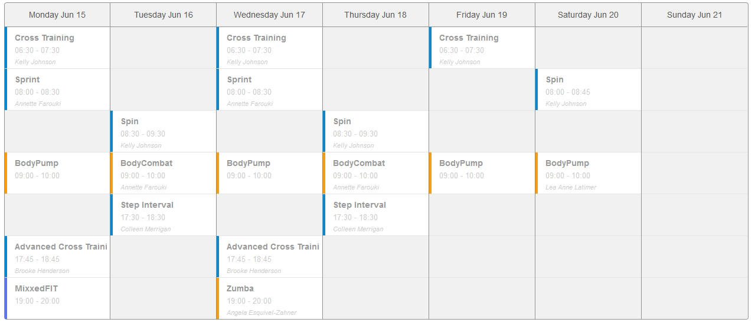

**info.html**

* create a form where the member can sign up for the course
* form should include
  + form fields:
    - Text field – required field: First Name
    - text field – required field : Last Name
    - input box: email
    - input box: phone
    - select list: Best way to reach: choices are : email, phone, owl and any additional methods you deem appropriate
    - check boxes with all the classes offered, allowing user to select all classes interested in
    - radio boxes: am or pm – allows user to enter their preferred class time
    - Any additional fields you would like to add
  + form should utilize the ***get*** request
  + form should submit to a thank you page **(thankyou.html)**
    - which displays the input fields (use the one we used with your lab)
    - be sure your thankyou page includes the site navigation so they can navigate back into the site
    - be sure your thankyou page includes the site’s stylesheet so it looks like the rest of the site pages

**thankyou.html**  - this page should NOT be on your navigation as the user is only displayed this page when they submit the form

* + use the same thankyou.html page used in the lab as it contains the javascript necessary to display the data
  + which displays the input fields (use the one we used with your lab)
  + be sure your thankyou page includes the site navigation so they can navigate back into the site
  + be sure your thankyou page includes the site’s stylesheet so it looks like the rest of the site pages